Joe Nelson

Mrs. Munther

English 9 Pre-IB

18 October 2018

Include a Captivating Title

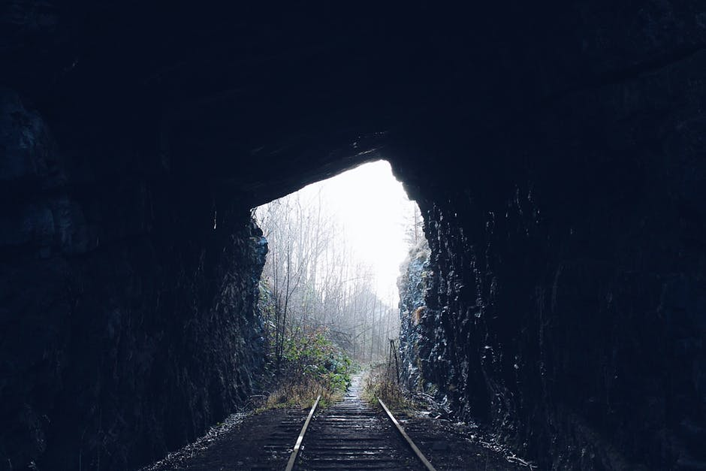

(Picture: Elisabeth Fossom. https://www.pexels.com/photo/view-of-tunnel-249097/ )

Paragraph indent and start writing here………

THIS DOCUMENT DEMONSTRATES

THE FORMAT FOR THIS MINI COMMENTARY.

PLEASE FOLLOW CAREFULLY!

…Finish here.